APEX · REFERENCE ENGAGEMENT · PRACTICE RC
Cold-Chain Excursion
From client scenario to measurable outcome

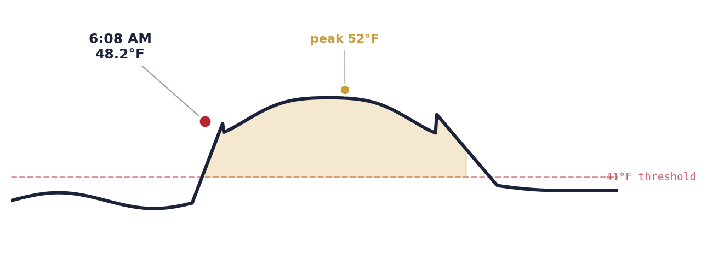
A comprehensive walkthrough of a single APEX scenario across the value-delivery chain — Scenario → Solution → Use Case → Service → Persona → KPI — covering how the scenario is solutioned on Microsoft-native deployment, which use cases the solution activates, what productized services it builds into, the persona cast that makes it operational, and the KPIs that attribute measured outcomes back to specific decisions.

Document type | Executive Walkthrough · Scenario-to-KPI
Practice | RC — Retail & Consumer
Service anchor | RC-E2E-03 Assortment & Pricing · RC-E2E-09 Product Tracking
Primary persona | Marisol Reyes · Store Operations Lead
Reference event | 6:08 AM · Dairy Case A3 · Big Box Store 100
Headline KPI | $1,313 write-off avoided · 90-second manager touch-time · 100% audit trail
Delivery waves | W1 Foundation · W2 Pilot · W3 Scale & Fuse
Companion artifacts | APEX-Stacked-Architecture-Narrated.html · Flow tab · APEX-Cold-Chain-Excursion-Build-Guide.md
Date | April 2026 · v1.0
Author | Deloitte Microsoft Technology Solutions & Practices

Contents

This document walks the Cold-Chain Excursion scenario through every link of the APEX value-delivery chain. Sections 1–2 set context. Sections 3–8 are the chain itself: one section per chain link. Section 9 projects the chain across the three delivery waves. Section 10 closes with the commercial envelope.

1 | The Reference Event — what actually happened at 6:08 AM
2 | Context — why this scenario exists as an APEX reference
3 | Scenario — the operational reality, unabstracted
4 | Solution — how APEX solutions this scenario
5 | Use Cases — derived from the solution
6 | Services — what gets productized for the client
7 | Personas — the operational cast that makes it work
8 | KPIs — measured outcomes attributed to decisions
9 | The Three Waves — W1 Foundation · W2 Pilot · W3 Scale & Fuse
10 | Commercial Envelope — time, cost, effort, durable value
A | Appendix — glossary, cross-references, artifacts index

SECTION 1 · OPENING FRAME

The Reference Event

At 6:08 AM on a Thursday in April, a refrigeration sensor at Big Box Store 100 reads 48.2°F. Dairy Case A3 — the floor-length open case carrying milk, yogurt, butter, and a daily-rotated selection of cheeses — has breached its 41°F setpoint. Over the next three hours and eleven minutes, temperatures drift between 47°F and 52°F before the case stabilizes. Doors open three times during the excursion window. Four hundred and twelve units across twenty-eight SKUs are on that shelf. Store opens to customers at 7:00 AM.
That is the scenario. Everything downstream — the solution architecture, the use cases, the productized services, the persona cast, the KPI rollups — exists to answer three questions about the 412 units and the fifty-two minutes between 6:08 AM and 7:00 AM:

- Which units are safe to sell, which should be marked down, and which must be destroyed?
- Who has the authority to make that call, and how do they make it in ninety seconds rather than twelve minutes?
- What evidence survives the decision — auditable, regulator-grade, attributable to the specific 6:08 AM event at the specific Dairy Case A3 at the specific Big Box Store 100?

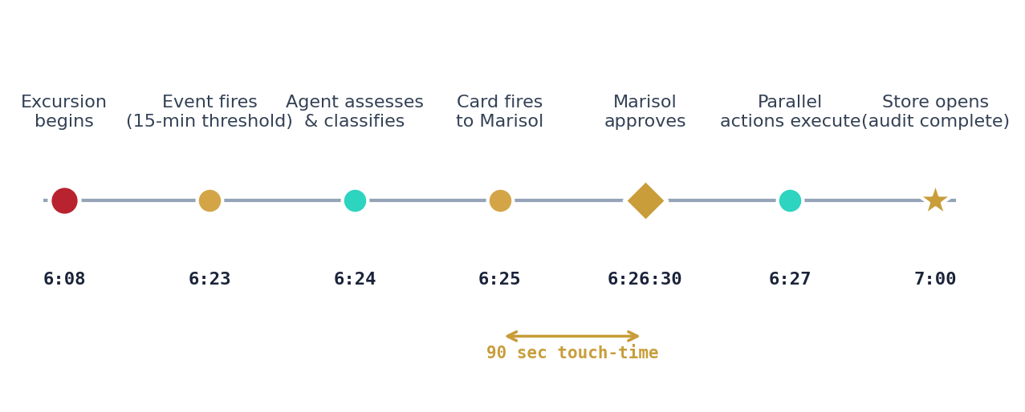
Figure 1.1 · The 52 minutes between excursion detection and store opening, narrated. Color-coded by action kind — crimson dot for the triggering event, amber for APEX process steps, teal for agent decisions, gold diamond for the HITL approval moment, gold star for the outcome.

Today, without APEX: Marisol Reyes, the Store Operations Lead, arrives at 6:45 AM. She walks the dairy case. She calls the refrigeration vendor from her mobile. She reads a printout of last-known temperatures that the overnight log kicked out. She phones her Food Safety Compliance Lead and waits for callback. She makes a judgment call in twelve minutes; 65% of that time went to gathering information, 35% to deciding. The store opens with her decision reflected on the shelf, but the evidence trail is a mix of paper log entries, text messages, and one emailed PDF. If FDA auditors ask about this event six months later, reconstructing what happened and why will cost a full day of Food Safety's time.

Tomorrow, with APEX: The excursion event fires at 6:23 AM — fifteen minutes after the threshold breach, the first moment at which it is confidently above-threshold. By 6:24 AM an agent has read the full temperature time-series, classified all 412 units against the FSMA 204 rule corpus, quantified the dollar impact of three proposed actions, and surfaced a decision card to Marisol's Teams mobile. At 6:16:30 AM — ninety seconds after the card arrives — Marisol approves. By 6:17 AM the POS has 91 markdown units loaded, a ticket is open at the refrigeration vendor's portal for the 289 destroy units, and the pull-team has a task waiting in the store-ops app. Every step has written an audit row referenced by trace-id trc_2026-04-23_0608_bb100_a3. The total write-off avoided, versus destroying all 412 units, is $1,313. The FDA auditor six months later can replay the event in five seconds from one query.

This document walks how that second reality is built, chain-link by chain-link.

SECTION 2 · CONTEXT

Why this scenario exists as an APEX reference

2.1 The five forces converge on a refrigerated case
APEX exists because five forces converged in late 2024 and through 2026: the decision-velocity gap that leaves 80% of operational signals as aged work; the agentic-AI inflection that crossed the enterprise viability threshold; the data-sovereignty and PII complexity that forces tokenization; regulatory acceleration including the FDA's FSMA 204 rule that took effect in 2026; and a knowledge-worker capacity shortage driven by retiring domain experts. Cold-Chain Excursion sits at the intersection of all five. It is the scenario that exercises every plane of the APEX architecture — integration, data, schema, reasoning, governance, identity, experience, feedback — and does so against a regulatory deadline that turned preference into requirement.
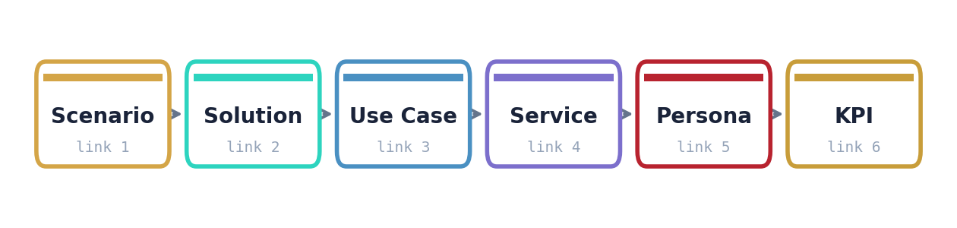
Figure 2.1 · The APEX value-delivery chain. Every engagement walks these six links in sequence. Sections 3 through 8 of this document take each link in turn.

2.2 Why RC carries the anchor
Of the seven APEX Practices — RC (Retail & Consumer), HLS (Healthcare & Life Sciences), ER (Energy & Resources), AXLE (Industrial & Manufacturing), TMT (Technology, Media & Telecom), TH (Travel & Hospitality), and ICE (Industrial & Commercial Equipment) — the RC Practice anchors the reference because its data footprint touches the highest number of canonical schemas and its event cadence is dense enough to generate meaningful volume inside a single pilot. The Cold-Chain Excursion scenario within RC touches five canonical schema families (SCML, MERML, CXML, plus two new sub-entities authored in Wave 1) and calls eight MCP servers during a single 17-minute orchestration window.

2.3 Why this document exists
Three conversations need to happen with the same material but different emphasis: the CFO and CEO need to see a credible operational-to-financial story; the Food Safety Lead and General Counsel need to see a regulator-grade evidence story; the CIO and Enterprise Architect need to see a Microsoft-native delivery story that does not destabilize the estate. This document walks the chain in a form that serves all three — organized around the canonical chain pattern so each reader can enter at the link that matters to them.

Independence note. Throughout this document, references to the Deloitte-Microsoft working relationship use the terms "Deloitte's Microsoft practice," "DMTSP," "Microsoft platform capabilities," or "Microsoft-native deployment." Terms implying partnership, alliance, or strategic alliance are deliberately not used, in keeping with audit-independence requirements. APEX is Deloitte-delivered; it runs on Microsoft technology; the two statements are distinct.

CHAIN LINK 1 · SCENARIO

Scenario

The Scenario link of the APEX value-delivery chain is the customer's operational reality stated without abstraction. It is not yet a solution. It is the thing that has to be true before a solution can be designed against it.

3.1 The situation
Big Box Store Company operates 2,400 stores across North America. Each store carries approximately 1.8 refrigerated fixtures in the dairy category alone, with additional fixture counts in deli, produce, frozen, and prepared-food departments. On an average week the network experiences between 1.5 and 3 cold-chain excursions per store — events in which a refrigerated fixture drifts above its FSMA-compliant setpoint for long enough to trigger a food-safety judgment call on the affected inventory.
The ambient conditions of each excursion matter. A dairy case that briefly exceeds threshold during a morning restocking with doors open is a different event from the same case drifting steadily above threshold for four hours overnight because a compressor is failing. The specific SKU mix at the time of the event matters — a case loaded with fresh milk jugs has different shelf-life economics than the same case loaded with pre-packaged hard cheeses. The time of day matters — an excursion that resolves before store opening carries different operational implications than one discovered mid-shift with customers already shopping.

3.2 The current-state response
The response today, across all 2,400 stores, is a hand-off chain made of phone calls, text messages, printed logs, and in-person walk-throughs. The sequence typically runs:
- The Store Operations Lead (or designated closing manager) discovers the excursion during morning readiness or receives notification from the refrigeration monitoring system.
- The Lead walks the affected case and makes a visual assessment of the inventory. This takes between four and eight minutes depending on case size and SKU count.
- The Lead contacts the Refrigeration Vendor's service line to determine whether a service ticket should be opened immediately or whether the case is expected to recover. Phone hold times vary between two and twenty minutes.
- The Lead pulls the overnight temperature log (printed nightly or accessible via a vendor portal with a shared-credential login).
- The Lead contacts the Food Safety Compliance Lead for a judgment call on whether the observed excursion profile requires markdown, destroy, or allows sell-through. This contact is typically by phone and frequently involves leaving a voicemail and waiting for callback.
- Once a disposition is agreed, the Lead directs the Pull Team to physically execute. Markdown units are moved to a clearance rack and tagged with printed markdown stickers. Destroy units are pulled to a designated location and logged by hand for waste pickup.
- The Inventory Control function updates the store's inventory position manually or by overnight batch from shrink entries. Variance reports are generated weekly or monthly.
- The Food Safety Compliance Lead enters the event into a regulatory log for FSMA audit trail purposes. This entry typically happens within 24 hours and is the primary artifact available to FDA auditors.

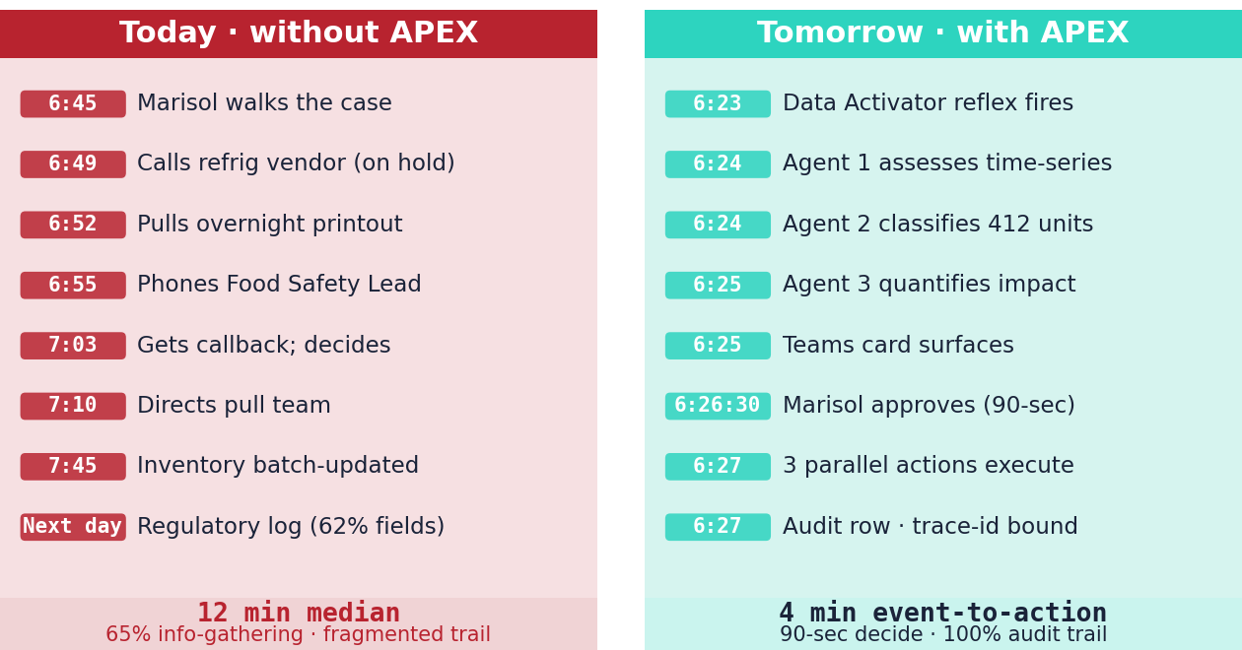
Figure 3.1 · The same 52 minutes, compared. Today the store manager is consumed gathering information; tomorrow the manager is consumed deciding. The decision time stays — the information-assembly time disappears.

3.3 The friction, quantified
Measured over a representative four-week period at a reference store, the current-state response produces the following friction profile:
Dimension | Typical value | Implication
Time from excursion detection to manager walkthrough start | 17 min median | Store-opening readiness compressed
Time spent gathering information (phone calls, log lookup, walkthrough) | 65% of total response time | Manager attention consumed by data assembly
Time spent deciding | 35% of total response time | Actual judgment work is a minority of effort
Total response cycle time, detection to disposition | 12 min median, 28 min p95 | Decisions often post-date store opening
Food Safety Lead callback median | 8 min | Lead waits; decision blocks
Regulatory log entry cycle time | 8–24 hours | Evidence gap window for auditors
Regulatory log completeness (fields) | 62% fully-populated fields | Auditor follow-up probability high

The friction composes to a materially worse outcome than the underlying economics warrant. Food-safety regulations are not being violated; the Lead and the Food Safety Compliance Lead are doing the right things in the right order. The problem is that the cost of doing those things within a narrow store-opening window is high enough that corners emerge elsewhere — shortcut phone calls, assumed-safe sell-through, abbreviated log entries. Those shortcuts are what makes the response system fragile.

3.4 The scope of the scenario
For the purposes of this document, the scenario includes every event where a refrigerated fixture at a Big Box Store breaches an FSMA-governed temperature setpoint for sufficient duration to require a food-safety disposition judgment. It specifically includes:
- Dairy, deli, produce, prepared-food, and frozen fixtures.
- Compressor failure, door-left-open, power interruption, and electronic-control-drift root causes.
- Single-fixture and adjacent-fixture cluster events.
- Events discovered during open-store hours and events discovered at store-opening.
It specifically excludes:
- Ambient-temperature product (shelf-stable groceries, dry goods, personal care).
- Events detected by customer complaint rather than sensor telemetry (a distinct scenario addressed separately).
- Power-outage events affecting the entire store (a business-continuity scenario with separate regulatory overlay).

CHAIN LINK 2 · SOLUTION

Solution

The Solution link is how APEX answers the Scenario. It is an architectural description — what runs, where it runs, what contracts bind the components, how humans stay in charge of the decisions that matter.

4.1 The solution in one sentence
A real-time perishables-integrity agent that fuses SKU-level elasticity with FSMA 204 lot provenance, runs under a manifest-governed orchestration, surfaces a single decision card to a named manager within the store's first hour of operation, executes three parallel downstream actions on approval, and emits a regulator-grade audit row that attributes measured outcomes — write-off avoided, manager time returned, audit-trail completeness — to the specific trace-id of the event.

4.2 The architectural components
The solution is not one thing. It is a choreographed composition of components drawn from the ten-layer APEX stack. Each component has a contract with its neighbors — typed inputs, typed outputs, classification propagation, trace-id discipline. The components that participate in this specific scenario, in the order they are touched during a live event, are:
Order | Component | Plane | Role in this scenario
1 | Refrigeration telemetry (OPC-UA) | Integration | Source stream — sensor readings every 30 seconds
2 | Real-Time Hub (Eventstream) | Integration | Streams ingest into Bronze Eventhouse without transformation
3 | Bronze Eventhouse | Data | Raw landing with Purview classification at ingest
4 | Tokenizer | Governance | Deterministic tokenization of any classified field before Silver
5 | Silver canonical schemas | Schema | SCML.Lot, SCML.Inventory, SCML.Fixture, SCML.SensorReading, MERML.Price, MERML.Markdown, MERML.Elasticity, MERML.Transaction
6 | Gold agent-safe views | Schema | gold.sku_at_risk, gold.markdown_candidate, fn_excursion_window
7 | Entra managed identities | Identity | Per-agent service principals with typed scope
8 | MCP servers (8 total) | Integration | Typed, contract-validated agent tools with trace instrumentation
9 | Data Activator reflex rule | Integration | Watches Bronze for threshold breach and fires the event
10 | Orchestrator (Azure AI Agent Service) | Orchestration | DAG-sequences four agents and a HITL gate
11 | Agent 1 — Assess | Reasoning | Reads excursion time-series, characterizes severity
12 | Agent 2 — Classify | Reasoning | Runs FSMA 204 policy corpus, produces per-SKU disposition
13 | Agent 3 — Quantify | Reasoning | Turns classification into dollars
14 | HITL gate | Experience | Surfaces Adaptive Card to Marisol via Teams
15 | LEDGER | Governance | Receives pending-decision record, then approval, then audit rows
16 | Agent 4 — Act | Reasoning | Executes three parallel downstream actions
17 | Vendor Portal MCP | Integration | Creates refrigeration service ticket
18 | KPI attribution | Feedback | Closeout audit row emits measured outcomes bound to trace-id

Eighteen components. One scenario. The companion artifact APEX-Stacked-Architecture-Narrated.html renders all eighteen as a live, clickable flow in its Flow tab. This document narrates what each does.
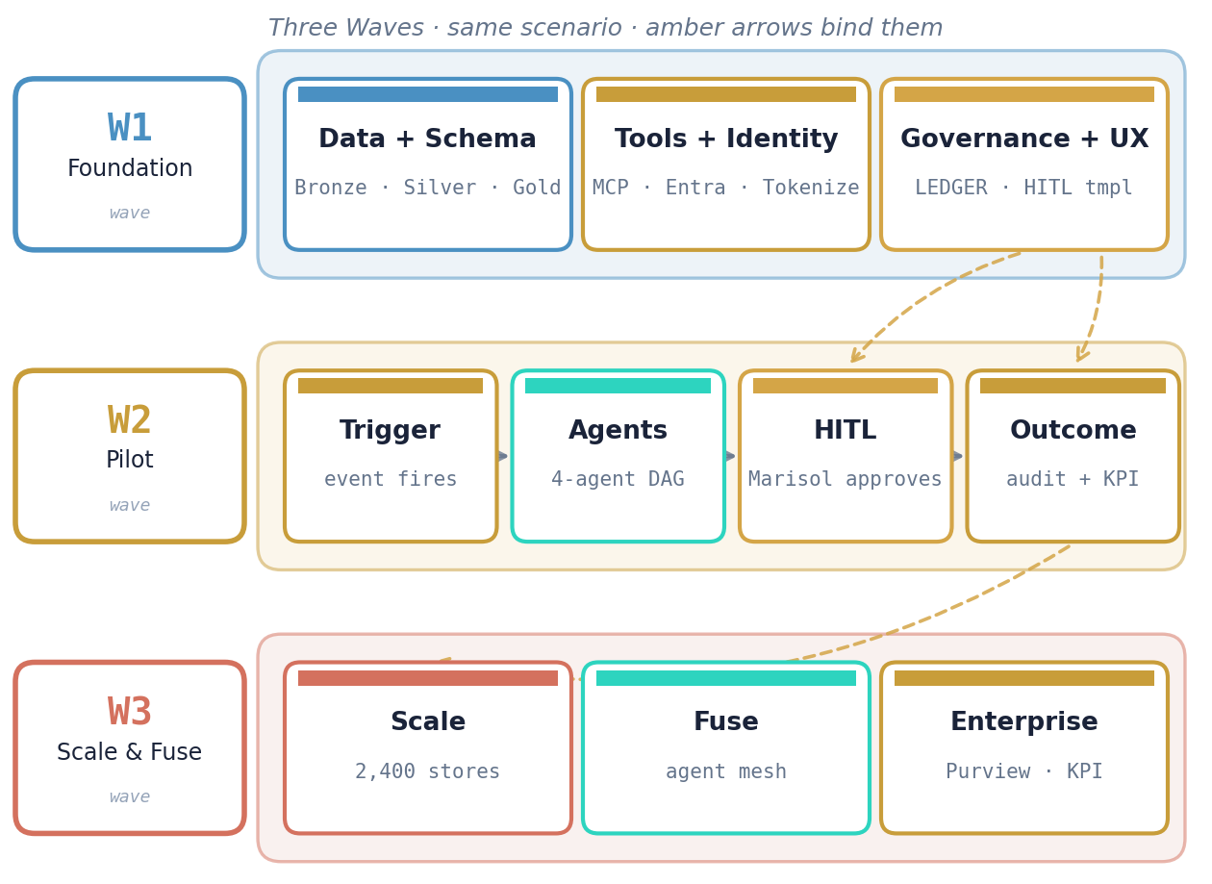
Figure 4.1 · The architectural components grouped by wave. W1 establishes the substrate (data, schema, tools, identity, governance, UX template). W2 runs the live scenario end-to-end. W3 scales and fuses. Three amber dashed arrows bind the waves into one continuous progression — W1 LEDGER and HITL template power the W2 HITL moment; W1 LEDGER accumulates W2 audit rows; W2 KPIs unlock W3 scaling.

4.3 Why this composition and not another
Three design commitments make this composition structurally different from a generic "AI-assisted operations" approach:

4.3.1 Manifest-driven, not model-driven
Every choice that could change between events — which LLM is used, which tools it can call, which policy corpus applies, what classification ceiling the agent runs under, which persona has approval authority — is declared in a Git-versioned manifest. The specific gpt-4o-2024-08-06 model pin in the Classify agent manifest is an implementation detail; tomorrow's model pin is a MINOR version bump. The manifest is the primary governance artifact, not the model.

4.3.2 Audit row, not log line
Every decision emits a 14-field structured row containing trace-id, three version stamps (manifest, policy, prompt), content-addressed input and output hashes, reasoning trace reference, HITL status and approver, downstream-effect cross-reference, and signature. Log lines describe what happened; audit rows reconstruct why. An agent that fails to emit a row is quarantined by the runtime.

4.3.3 HITL is first-class, not bolted on
The HITL gate between Quantify and Act is not a retro-fitted "human check." It is declared in the orchestration manifest as a first-class primitive. Its gate kind (ZERO_TOUCH, ACK_ONLY, HITL, or ESCALATION) is deterministically mapped from the classification severity. Marisol is named in the hitl-authority policy; her 300-second timeout escalates to Store Manager Jamie O'Connor, whose 900-second timeout escalates to a district manager. The escalation chain is a reviewable artifact, not a runtime surprise.

4.4 What the solution does not do
APEX is not a replacement. It does not:
- Replace the client's refrigeration-vendor relationship. The vendor keeps the refrigeration service contract; APEX opens tickets against the vendor's portal via MCP.
- Replace the POS or the ERP. Both remain the Systems of Record; APEX mirrors data into Bronze via CDC or Eventstream.
- Replace the Food Safety Compliance Lead's authority. The Lead stays on the escalation path for CRITICAL-severity events; the default path routes through the Store Operations Lead for the bulk of events.
- Replace the FSMA regulatory regime. The solution makes FSMA compliance auditable by construction; it does not change the underlying rules.

CHAIN LINK 3 · USE CASES

Use Cases

The Use Case link is the set of discrete operational patterns the Solution activates. One Solution typically enables multiple Use Cases — each Use Case is a bounded, testable, individually-measurable pattern that can be delivered as a piece of a larger engagement.
The Cold-Chain Excursion solution activates six primary use cases. Each is described below with its trigger, the agents involved, the HITL gate behavior, and the typical commercial envelope for delivering that use case in isolation.
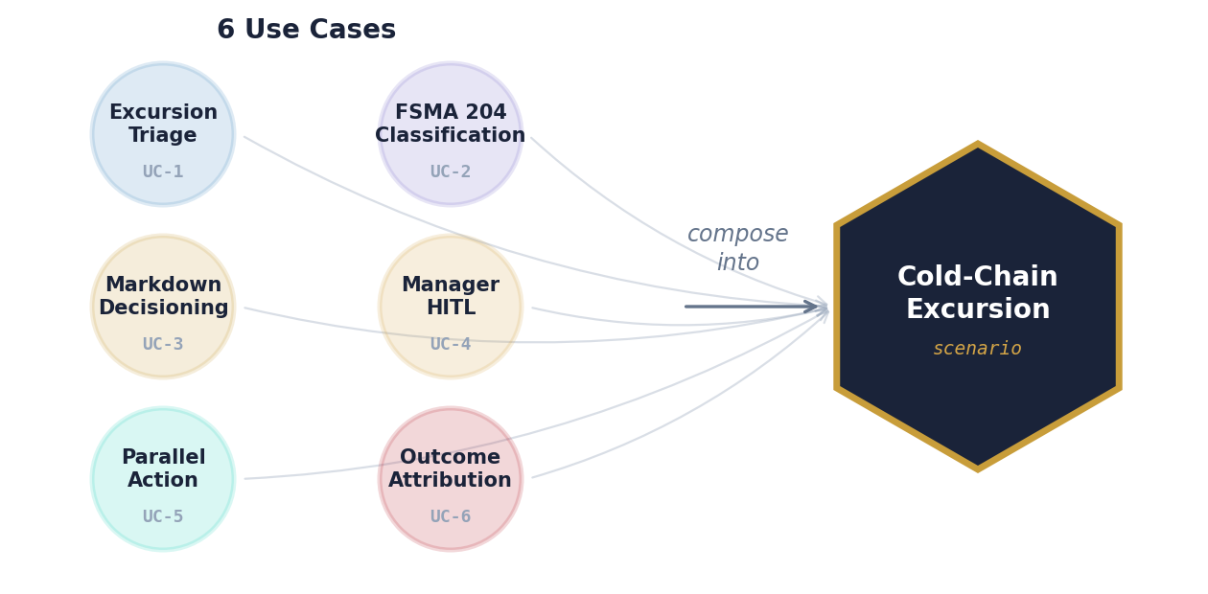
Figure 5.1 · The six use cases derived from the Cold-Chain Excursion solution. Each is individually deliverable, individually measurable, and individually commercially-envelopable — but together they compose the end-to-end scenario. Clients can stage consumption.

5.1 Use Case · Excursion Triage
The foundational pattern. Triggered by a Data Activator reflex detecting that a refrigerated fixture has breached its setpoint for more than 15 minutes. The Assess agent characterizes the excursion (peak temp, duration, avg temp, door-open events). Produces a structured assessment bound to the fixture and store. No HITL at this stage — the assessment is information-producing, not action-producing.
Trigger | Data Activator reflex, excursion ≥ 15 minutes
Agents | Assess
HITL gate | None (information-only)
Cycle target | < 90 seconds from trigger to assessment emission
Reusability | High — fires for every excursion, regardless of downstream path
Delivery if isolated | ~2 weeks · $200K–$400K · 6 story points

5.2 Use Case · FSMA 204 Policy-Classification
Activated immediately after Excursion Triage. The Classify agent joins the assessment against lot-provenance data (SCML.Lot with FSMA 204 Critical Tracking Events and Key Data Elements) and runs the tenant's policy corpus to produce per-SKU dispositions: sell-through, markdown, or destroy. This use case is the regulatory centerpiece — every disposition is tied to a specific policy rule version, and every rule version is tied to a specific LEDGER registration that an auditor can retrieve.
Trigger | Assessment emitted by Excursion Triage use case
Agents | Classify
HITL gate | None at this step (Classify produces recommendation)
Cycle target | < 60 seconds from assessment to classification
Reusability | High — same pattern applies to any policy-driven disposition decision
Delivery if isolated | ~3 weeks · $350K–$650K · 10 story points

5.3 Use Case · Markdown Decisioning
The Quantify agent takes the classification and turns it into dollars. It calls MERML.Price for current shelf prices, MERML.Elasticity for per-SKU markdown-response curves, and SCML.Lot for expiry windows. Produces three scenarios (sell-through value, markdown-recovered value, destroy write-off cost) with projected unit economics. This is the use case that changes a disposition list into a decision the manager can act on.
Trigger | Classification emitted by Policy-Classification use case
Agents | Quantify
HITL gate | None at this step
Cycle target | < 30 seconds
Reusability | High — applicable to any inventory-disposition decision
Delivery if isolated | ~2 weeks · $250K–$450K · 8 story points

5.4 Use Case · Manager-Approval HITL
The orchestrator pauses. An Adaptive Card fires to the named primary persona (Marisol Reyes for Big Box Store 100) via Teams. The card carries the full scenario context — excursion profile, at-risk units, proposed actions, dollar impact. Marisol has 300 seconds of hold-time to approve, modify, or reject. If no decision is recorded in that window, the approvals-mcp escalates to Store Manager Jamie O'Connor. If Jamie also does not respond within his 900-second window, the event escalates to a district manager. Every escalation step emits an audit row.
Trigger | Quantification emitted by Markdown Decisioning use case
Agents | None (approvals-mcp orchestrates the human decision)
HITL gate | HITL kind — agent pauses, human approves
Cycle target | < 120 seconds p50 manager touch-time (goal) · 300s timeout before first escalation
Reusability | High — the HITL gate pattern applies everywhere a named persona has threshold authority
Delivery if isolated | ~3 weeks · $400K–$750K · 12 story points

5.5 Use Case · Parallel Downstream Action
Post-approval, the Act agent orchestrates three parallel downstream actions: POS markdown upload (writes to SCML.Inventory and then through to the pricing engine); refrigeration-vendor ticket (creates a service record in the vendor's portal via vendor-portal-mcp); pull-team task (creates a prioritized task in the store-ops mobile app with the specific SKU list to pull). Each action emits its own child audit row cross-referenced to the parent trace-id. If any action fails, the composite audit row captures the partial state — this use case is idempotent and retry-safe.
Trigger | HITL approval recorded
Agents | Act
HITL gate | None (pre-approved)
Cycle target | < 30 seconds for all three parallel actions to complete
Reusability | Very high — the fan-out pattern applies to any multi-channel execution
Delivery if isolated | ~4 weeks · $600K–$1.1M · 16 story points (vendor-portal integration depth drives range)

5.6 Use Case · Outcome Attribution
The closeout use case. A final audit row emits with measured KPI fields bound to the trace-id: write-off avoided (dollars), time-to-brief (seconds from event to HITL card), manager touch-time (seconds), audit-trail completeness (percent), model and policy version stamps used by every agent in the run. This audit row is what rolls up to the Power BI dashboard and what an auditor retrieves six months later. Outcome Attribution is the link that turns a pilot into an enterprise case.
Trigger | Act completion
Agents | None (orchestrator emits directly to ledger-mcp)
HITL gate | None
Cycle target | < 10 seconds
Reusability | Very high — every APEX scenario needs this
Delivery if isolated | ~2 weeks · $200K–$400K · 6 story points

5.7 How the use cases compose
Individually, each use case is a deliverable. Together they compose into the Cold-Chain Excursion scenario. The composition is deliberate — a client can buy the first three use cases (Triage, Classify, Quantify) as a "Cold-Chain Insight" package without yet committing to HITL automation. The client can then add Use Cases 4–6 as a second phase once the decision-latency and attribution evidence proves out. This staged consumption is what makes the commercial envelope flexible; the architecture is not.

CHAIN LINK 4 · SERVICES

Services

The Service link is what gets productized. A Service is a named, subscribable APEX capability with a defined persona, SLO, commercial terms, and an anchor in the APEX Service Catalog (Design Reference Appendix B). A single scenario typically anchors to one or two named services that the client subscribes to via the tenant manifest.

6.1 Anchor services
The Cold-Chain Excursion scenario anchors to two RC services in the APEX Service Catalog:

RC-E2E-03 · Assortment & Pricing
The broader umbrella service for any scenario that touches pricing or markdown decisioning. Cold-Chain Excursion is one of several scenarios that subscribe to this service — Dynamic Markdown Optimization, Seasonal-Transition Planning, and Competitive Price Response are siblings. Commercial envelope is tied to the Practice Edition and the tenant's store count; a 250-store pilot carries a different envelope than a 2,400-store enterprise footprint.

RC-E2E-09 · Product Tracking
The lot-provenance and FSMA-204 compliance service. Where RC-E2E-03 owns the dollar side of the decision, RC-E2E-09 owns the regulatory side. Its presence in the subscription manifest is what commits the client to FSMA 204 lot-traceability ingestion at Silver (SCML.Lot with CTE and KDE bindings) and to regulatory-grade audit-row retention. RC-E2E-09 is sometimes subscribed independently by clients who are behind on FSMA 204 compliance and need the tracking backbone before they layer scenarios on top.

6.2 Service composition
A Service is not a monolith. Each of the two anchor services above is a composition of: canonical schema subscriptions, agent deployments, MCP tool registrations, HITL policy bindings, LEDGER policy corpus entries, Power BI semantic-model publications, and service-level commitments (latency, freshness, availability). The table below enumerates what RC-E2E-03 and RC-E2E-09 each commit the tenant to, for this scenario.
Commitment | RC-E2E-03 Assortment & Pricing | RC-E2E-09 Product Tracking
Canonical schemas | MERML.Price, MERML.Markdown, MERML.Elasticity, MERML.Transaction | SCML.Lot, SCML.Inventory, SCML.Fixture, SCML.SensorReading
Agents deployed | Quantify, Act (markdown path), rc-markdown-agent (W3) | Assess, Classify
MCP servers | merml-mcp | scml-mcp, policy-mcp (FSMA 204 corpus)
HITL policy | Markdown-authority threshold binding | FSMA 204 severity-to-gate-kind binding
Power BI | Markdown-outcome semantic model | FSMA 204 audit-trail completeness semantic model
SLO: classify / price retrieval | p95 < 250ms | p95 < 500ms
SLO: availability | 99.9% | 99.9%
Trust commitment | Classification propagation for pricing data | WORM retention for audit rows; legal-hold eligibility

6.3 Service subscription in the tenant manifest
A client subscribes to services by declaring them in the tenant manifest. For Big Box Store Co., the subscription block looks like:
"subscriptions": [
{ "service_id": "RC-E2E-03", "service_version": "v1.2.0" },
{ "service_id": "RC-E2E-09", "service_version": "v1.0.0" }
]
Version pinning is deliberate. When APEX releases v1.3.0 of RC-E2E-03, the tenant decides when to upgrade. PATCH bumps are automatic; MINOR and MAJOR bumps require explicit accept-upgrade HITL gates. This is how tenants stay on stable versions while APEX continues to evolve.

6.4 Derived services — additional productization paths
The Cold-Chain Excursion scenario anchors two services as described above. It also informs the potential productization of additional services that share the same architectural substrate. These are not yet in the APEX Service Catalog as of this document's date; they are candidates that emerge from the engagement and are typically proposed by the Practice Lead to the APEX Service Catalog Committee for promotion to a future Edition.

Candidate: RC-E2E-11 · Perishables Integrity Response
A potential consolidation service that wraps Cold-Chain Excursion with its siblings — produce-ripeness response, frozen-thaw-refreeze response, and prepared-foods-holding-time response — into a single subscription. Rather than a client buying the Excursion-specific capability, they would buy the Perishables Integrity bundle and get all four patterns. This is the shape the service is likely to take in v2.0.0 of the RC Edition.

Candidate: RC-E2E-12 · Regulator-Grade Evidence Service
A horizontal service — usable by any RC scenario that generates regulatory evidence — offering pre-built FDA FSMA 204 auditor workbench, state-health-department complaint response, and class-action discovery support. Cold-Chain Excursion generates the kind of evidence this service exposes; productizing the exposure layer separately would let clients who do not need the full decisioning capability still buy the audit-trail backbone.

Candidate: RC-E2E-13 · Manager Time-Return Service
Cold-Chain Excursion returns 5.2 hours per shift to the Store Operations Lead. Similar time-return patterns exist in Returns-Fraud Triage, On-Shelf-Availability Task Generation, and Shift-Handover Note Automation. Productizing Manager Time Return as a cross-scenario service — measured by aggregate hours returned per manager per week, against a baseline established during Discovery — would sell on a different commercial logic than the per-scenario pattern, and may appeal to CHROs who prioritize managerial capacity over category P&L.

Why this matters for commercial conversations. A client who sees only the anchor services (RC-E2E-03 + RC-E2E-09) sees a cost-line item. A client who sees the derived-service candidates sees an asset roadmap: this engagement is not the end-state, it is the first proving ground for a multi-service offering that grows with them. The seller's job is to make the derived-service logic credible without overselling — the candidates are real architecture, not speculative features.

CHAIN LINK 5 · PERSONAS

Personas

The Persona link is the human-role cast that makes the scenario operational. Persona depth is what separates an architecturally correct solution from one that lands on the floor. APEX models one primary persona — the named person who uses the solution and makes the HITL decision — and three to five secondary personas who oversee, execute, approve, or benefit from the decision.

7.1 Primary persona
PRIMARY · Marisol Reyes · Store Operations Lead · Big Box Store 100
Approves markdown and destroy actions above threshold via Teams Adaptive Card; decision writes to audit row. Accountable for store-opening readiness, operational-shift handoff, and store-level P&L on shrink. Receives the HITL card on her Teams mobile within seconds of excursion detection. Median touch-time target is 90 seconds; has full authority up to a markdown of 50% and a destroy value of $5,000; events above those thresholds escalate to Store Manager.

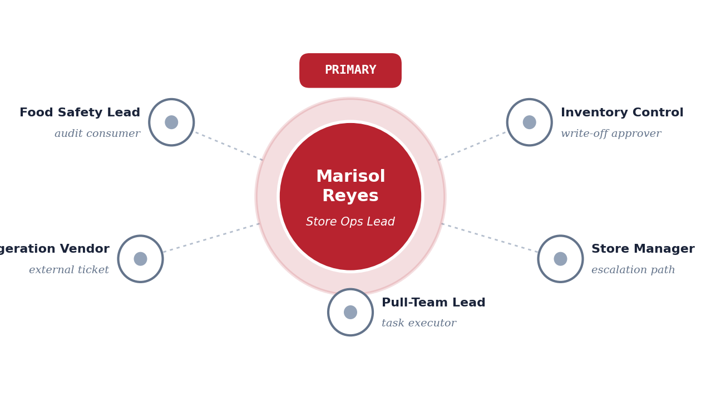
Figure 7.1 · The persona constellation. Marisol Reyes holds the primary role at the center; five secondary personas orbit with distinct functions — task executor, escalation path, write-off approver, external ticket, audit-trail consumer. Persona depth is what turns an architecturally correct solution into one that lands operationally.

Marisol is named, not generic. "Store Operations Lead" is a title; Marisol Reyes is a person. The hitl-authority policy registered in LEDGER binds to her named identity (resolved through Entra group-lookup at runtime). The Adaptive Card fires to her Teams endpoint. The audit row records her approval. This specificity is what makes the scenario operational rather than aspirational.

7.2 Secondary personas
Five secondary personas each carry a distinct role in the scenario. The roles are deliberate; APEX does not invent roles, it maps to the roles that already exist in the client's store-operations handbook. The first column below names the role; the second describes what the role does in this specific scenario.
Role | Function in the Cold-Chain Excursion scenario
Pull-Team Lead | Task executor — receives the prioritized pull task in the store-ops mobile app with the specific SKU list. Executes physical pull of markdown and destroy units. Logs completion to audit row.
Store Manager | Escalation path — receives Adaptive Card if Marisol does not respond within 300 seconds. Has authority equivalent to Marisol plus override of Marisol's rejections. Jamie O'Connor at Big Box Store 100.
Inventory Control | Write-off approver for any destroy action above $5,000 dollar value. Second-stage HITL gate for high-value events. Reconciles store-level inventory position against the action audit rows.
Refrigeration Vendor | External ticketed party — service ticket is created in the vendor's portal (ServiceChannel, Corrigo, or Ecotrak depending on the client) via vendor-portal-mcp. Vendor technician dispatched according to the vendor's own SLA.
Food Safety Compliance Lead | Audit-trail consumer. Does not approve individual events in the default path, but has direct query access to every audit row bound to an FSMA 204 CTE. Owner of the regulatory reporting workflow to FDA and to state health authorities.

7.3 Why persona depth matters
A seller who names only the primary persona says "we built something for the store manager." A seller who names the full cast shows the buyer a complete operating model: who executes, who escalates, who approves beyond threshold, who the vendor touches, who the auditor calls. Specificity at this depth is the credibility signal that separates APEX from a slide-deck pitch.
Persona depth also matters for change management. When the engagement rolls out, the client's Field Enablement team has to train all six named roles — not just Marisol. The six-role inventory informs training plan scope, org-readiness assessment, and the Wave 2 exit criteria (Marisol self-reports time-returned; the Pull-Team Lead self-reports task-clarity; the Food Safety Lead self-reports audit-trail completeness).

7.4 Persona-to-plane mapping
Each persona interacts with a specific plane of the APEX architecture. Understanding the mapping is how we know what we need to build on the Experience Plane specifically for each role.
Persona | Plane(s) touched | Surface
Marisol (Primary) | Experience | Teams Adaptive Card (mobile)
Pull-Team Lead | Experience | Store-ops mobile app task queue
Store Manager | Experience | Teams Adaptive Card (escalation) · Power BI dashboard
Inventory Control | Experience · Feedback | Dashboard drill-through · approval card for high-value events
Refrigeration Vendor | Integration | Vendor portal (external — APEX does not touch their UI)
Food Safety Compliance Lead | Governance · Feedback | LEDGER auditor workbench · Purview Unified Catalog

CHAIN LINK 6 · KPIS

KPIs

The KPI link is where the chain closes. APEX's signature is that every KPI attributes back to the specific decision audit row that produced it — not just to the aggregate. The distinction matters because it is what makes the KPI durable under audit.

8.1 Per-event KPIs
A Cold-Chain Excursion event emits a closeout audit row carrying the following measured KPI fields. Each is bound to the specific trace-id of the event. A Power BI dashboard rolls them up weekly; drill-through on any aggregated cell returns the individual trace-id that contributed.
KPI | Measurement | Target (W2 Pilot) | Target (W3 Scale)
Write-off avoided ($) | Destroy-all baseline value minus actual write-off value | $1,313 per event | $42M per year network-wide
Time-to-brief (min) | Excursion detection → HITL card surfaced | 8 min median | < 10 min p95
Manager touch-time (sec) | HITL card displayed → decision recorded | 90 sec median | < 120 sec p95
Audit-trail completeness (%) | Required fields populated on every audit row | 100% | 100%
Classification agreement (%) | Agent classification vs Food Safety Lead retrospective review | 95% | 97%+
Manager hours returned (per shift) | Baseline shift-time spent on cold-chain response minus actual | 5.2 hrs/shift | 22,464 hrs/day network-wide
First-decision rate (%) | Events resolved at Marisol's HITL without escalation | 85% | 92%

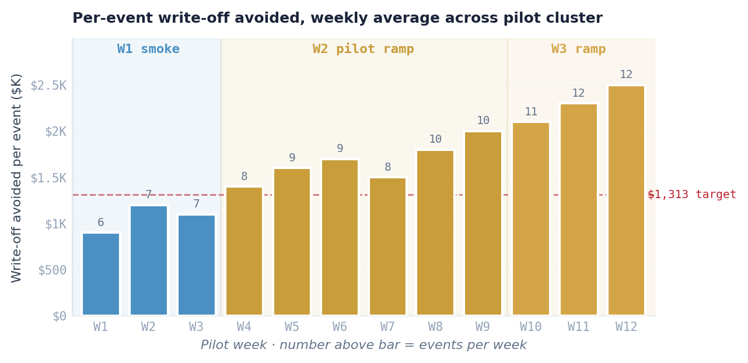
Figure 8.1 · Weekly average write-off avoided per event, trending across 12 pilot weeks. W1 smoke-test events establish baseline discipline; W2 pilot events cross the $1,313 per-event target by week 4; W3 ramp confirms the trend holds at enterprise scope. Number above each bar is events-per-week.

8.2 Derived KPIs for commercial cases
Beyond the per-event operational metrics, three derived KPIs anchor commercial conversations. They are computed from the per-event metrics aggregated over time. Each attributes back to specific events.

8.2.1 Network-wide Write-Off Avoided
The headline financial metric. Computed as SUM(writeoff_avoided_usd) across all cold-chain closeout audit rows over a trailing 52 weeks. At 85 events/week × 2,400 stores × $1,313 avg avoided per event, the annualized number is $42M. An auditor retrieving the specific trace-ids that contribute can see every event's math.

8.2.2 Manager Capacity Returned
The operational metric that matters to CHROs and store operations leadership. Computed as SUM(time_saved_per_event) projected against shift schedules. 5.2 hours per shift × 1.8 shifts per day × 2,400 stores = 22,464 hours per day of managerial attention redirected from information-assembly to higher-value work. This is the metric that drives conversations about what Marisol does with the recovered time.

8.2.3 Audit-Trail Completeness
The regulatory metric. Computed as the percentage of events whose audit rows carry all 14 required fields, every version stamp, and a verifiable signature. The target is 100%. The metric matters because it is the direct answer to the FDA FSMA 204 auditor's question: "how complete is your traceability record?" Answer: retrieve the LEDGER view filtered to event_kind = 'cold_chain_closeout' and audit_trail_completeness_pct < 100. If the result set is empty, completeness is 100%.

8.3 KPI attribution in the audit row
The closeout audit row — emitted once per resolved event — carries the following structure relevant to KPI attribution:

{
"trace_id": "trc_2026-04-23_0608_bb100_a3",
"event_kind": "cold_chain_closeout",
"event_ts": "2026-04-23T06:17:12Z",
"tenant_id": "bigbox",
"manifest_version": "rc-cold-chain-orchestration-v1.2.0",
"policy_version": "fsma-204-cold-chain-v1.0.0",
"prompt_version": "agent-classify-v3.1.0-sha:abc123",
"kpi_fields": {
"writeoff_avoided_usd": 1313,
"time_to_brief_sec": 480,
"manager_touch_time_sec": 90,
"audit_trail_completeness_pct": 100,
"escalation_required": false,
"first_decision": true
},
"downstream_effect_ref": ["audit_row_act_markdown", "audit_row_act_vendor", "audit_row_act_pull"],
"signed_row_hash": "hmac:8f2a..."
}

8.4 What the KPI attribution unlocks
The specific binding of each KPI value to a specific trace-id makes three business outcomes possible that are not available with aggregate-only metrics:
- The CFO can ask "show me the five events that contributed the most to last quarter's write-off-avoided number" and get answer rows from the audit table within seconds — not from a pivot of aggregated BI data.
- The Food Safety Compliance Lead can ask "which audit trails were less than 100% complete last month and why" and get a filterable list with the specific gap per row.
- The Practice Lead can ask "which events did the Classify agent disagree with the Food Safety Lead on" and get the inputs, outputs, and reasoning-trace reference for each disagreement — feeding policy-manifest evolution.
These queries are how W3's feedback loop becomes data-driven. The KPI attribution is not just reporting — it is the substrate of manifest evolution.

SECTION 9 · WAVE PROGRESSION

The Three Waves

The same chain — Scenario → Solution → Use Case → Service → Persona → KPI — projects across three delivery Waves. W1 Foundation is prerequisite work that enables the scenario. W2 Pilot is the scenario running live at proof-point scale. W3 Scale & Fuse is enterprise scope plus cross-scenario fusion into agent meshes.
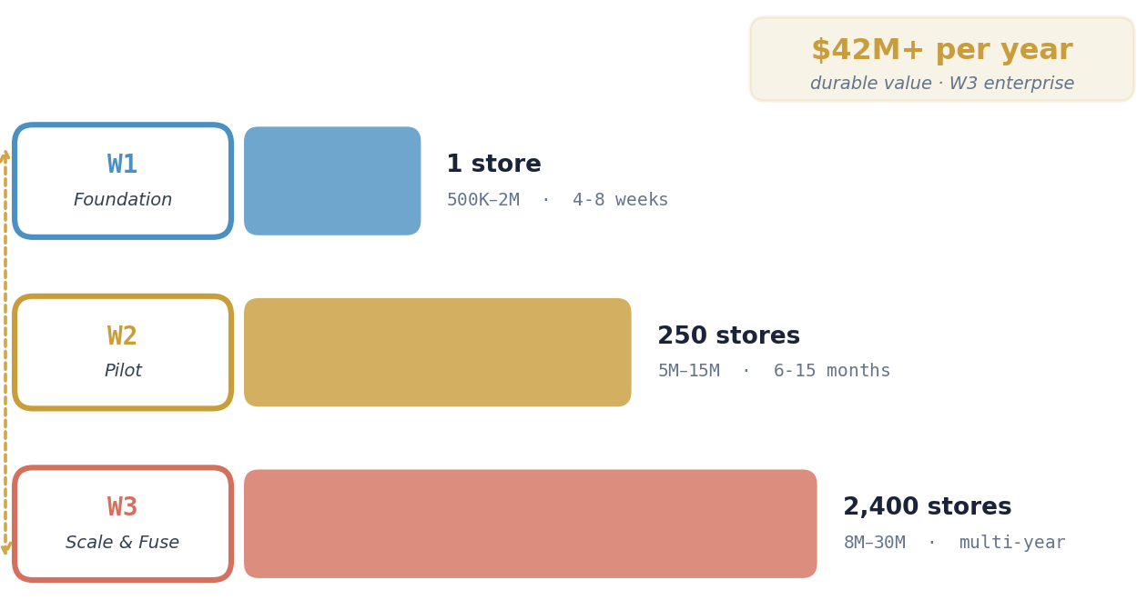
Figure 9.1 · The three-wave progression. Scope expands from 1 anchor store to 250-store pilot to 2,400-store enterprise. Commercial envelope grows from $500K–$2M in W1 to $8M–$30M in W3. Annualized durable value at W3 enterprise run-rate reaches $42M+/year.

9.1 Wave 1 · Foundation
W1 is the one-time investment per tenant. It produces the rails that make the scenario possible and make every subsequent scenario cheap. Ten distinct build steps take the tenant from "we have an Azure subscription" to "the end-to-end smoke test passes." The steps are enumerated in depth in the companion APEX-Cold-Chain-Excursion-Build-Guide.md; they are summarized here at chain-projection level.
W1 step | What the chain link looks like in W1
Scenario | No live scenario yet — W1 authors the synthetic-event injector that will prove W2 readiness
Solution | Full 18-component architecture stood up: Bronze, Tokenizer, Silver, Gold, MCP servers, Entra identities, LEDGER, HITL Teams template, all live and smoke-tested
Use Case | No use cases firing in production; each of the six use cases gets a synthetic-event smoke test showing round-trip in <5 seconds
Service | Services RC-E2E-03 and RC-E2E-09 registered in tenant manifest at pinned versions; subscription-level smoke tests pass
Persona | HITL authority policy for Marisol registered in LEDGER; Teams bot installed and verified on Marisol's mobile endpoint; escalation chain to Jamie O'Connor and District Manager verified with synthetic timeout
KPI | Power BI dashboard scaffold published with empty panels; Direct Lake semantic model refreshes in <1s on synthetic data

W1 duration | 4–8 weeks
W1 effort | ~40 story points
W1 envelope | $500K–$2M
W1 exit criteria | 10 hard gates checked in the Build Guide §13.1

9.2 Wave 2 · Pilot
W2 is where the scenario becomes real. 250 stores — typically the North America anchor cluster — run the live scenario end-to-end. The full chain fires for every excursion event. The target is 30 consecutive events handled with no pipeline failure before the Steering Committee exits the pilot.
W2 step | What the chain link looks like in W2
Scenario | Live cold-chain excursion events firing at 250 stores · ~8 events per week across the pilot cluster
Solution | Full architecture in production with live trace-id discipline; every component emitting audit rows; orchestrator version-pinned
Use Case | All six use cases firing per event — Triage, Classify, Quantify, HITL, Act (parallel fan-out), Outcome Attribution
Service | Both anchor services billing at pilot-tier commercial terms; service-level agreements measured and reported weekly
Persona | Marisol and 5 secondary personas active at every pilot store; median touch-time <120 seconds by event 10; first-decision rate >80%
KPI | Write-off-avoided tracking within ±10% of pre-pilot baseline model; 100% audit-trail completeness on every event; CFO drill-through from aggregate to trace-id working

W2 duration | 6–15 months
W2 effort | ~35 story points initial + ongoing enablement
W2 envelope | $5M–$15M
W2 exit criteria | 10 numbered checks in the Build Guide §22

9.3 Wave 3 · Scale & Fuse
W3 is where the scenario meets the enterprise and where it stops running alone. Scope expands from 250 stores to all 2,400 stores. Fixture classes expand from dairy/deli/produce to the full refrigerated-and-frozen footprint. And — most importantly — the cold-chain agent stops making decisions in isolation. It fuses with the Dynamic Markdown agent, which understands category-wide elasticity, and with the Loyalty Churn agent, which understands top-tier customer impact. The three agents together form the Perishables Economics Mesh.
W3 step | What the chain link looks like in W3
Scenario | 85 events per week across 2,400 stores; ambient conditions include all perishable fixture classes; scenario couples to customer-signal at fusion boundary
Solution | Same 18-component substrate + fusion manifest rc-perishables-economics-mesh-v1; cross-agent event-bus operational; Purview enterprise lineage live
Use Case | Original 6 use cases + 2 fusion use cases (SKU-specific markdown depth; proactive loyalty outreach to top-tier members affected in 48h window)
Service | RC-E2E-03 and RC-E2E-09 at enterprise-tier commercial terms; rc-markdown and rc-loyalty-churn services added to subscription; candidate consolidation into RC-E2E-11 Perishables Integrity Response
Persona | Primary persona population scales from 250 named individuals to ~4,800 (2,400 stores × ~2 primaries for coverage); district managers active on >$10K events; corporate FSQA active on multi-store incidents
KPI | Network-wide write-off-avoided run-rate $42M/year; margin on markdown units 35% → 52% (fusion effect); 22,464 hours/day of manager capacity returned; 0 top-tier customer complaints from affected 48h-window members

W3 duration | Multi-year rollout
W3 effort | ~50 story points initial + ongoing mesh expansion
W3 envelope | $8M–$30M
W3 exit criteria | 6 numbered checks in the Build Guide §29

9.4 The cross-wave arrows
Three structural dependencies bind the waves into one progression. They are not architectural coincidences — they are the load-bearing connections that make the Wave model coherent.
W1 HITL template powers W2 HITL gate. The Teams Adaptive Card template registered in W1 Step 12 is the exact template that fires to Marisol during every W2 event. The template is authored once, tested once, and lives in the tenant manifest forever. Updating it is a MINOR version bump that propagates to every subsequent event — not a new build.

W1 LEDGER accumulates W2 audit rows. The audit-row Delta store provisioned in W1 Step 11 becomes the substrate that W2 writes into. 52 weeks into W2, LEDGER holds ~420 parent audit rows and ~1,680 action-child rows for this one scenario at a 250-store pilot. At W3 enterprise scale those numbers multiply by ~10×. The query patterns that W3's feedback loop runs (pattern detection on HITL overrides; manifest-evolution proposals) operate against the same LEDGER, not a separate analytics store.

W2 KPIs unlock W3 scaling. The Steering Committee approval to exit W2 and scale to W3 is not a vote of confidence — it is a reading of the KPIs emitted over the pilot window. Write-off-avoided within ±10% of model; manager touch-time under 120 seconds at p95; audit-trail completeness at 100%. The attribution-grade KPI structure is what makes the exit gate auditable on its own terms.

SECTION 10 · COMMERCIAL ENVELOPE

Commercial Envelope

The engagement encompasses four commercial tiers corresponding to the Approach stage (Discovery and SoW build-out), Wave 1 Foundation, Wave 2 Pilot, and Wave 3 Scale & Fuse. Each carries a distinct cost-envelope range, duration, and deliverable signature. The ranges below are anchored in the APEX Service Catalog pricing grid for the RC Edition at the v2.0.0 subscription tier; a specific engagement prices within the range based on store count, SOR integration complexity, and the client's existing Microsoft platform maturity.
Tier | Duration | Cost envelope | Effort | Primary deliverable
Approach | 2–4 weeks | $150K–$400K | 18 SP | Discovery report · Schema mapping · SoW
W1 Foundation | 4–8 weeks | $500K–$2M | 40 SP | Tenant rails live · end-to-end smoke green
W2 Pilot | 6–15 months | $5M–$15M | 35 SP + ongoing | 30-event streak · KPIs proven · SteerCo exit
W3 Scale & Fuse | Multi-year | $8M–$30M | 50 SP + ongoing | 2,400 stores · fusion mesh · $42M/yr run-rate

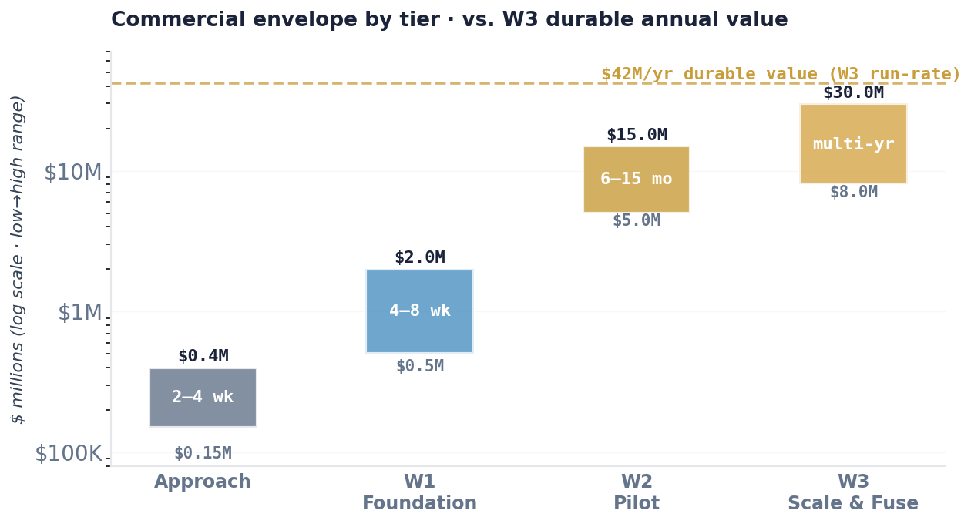
Figure 10.1 · The commercial envelope visualized on a log scale. Each bar shows the low-to-high range for that tier. The gold dashed line marks the $42M/year durable value at W3 enterprise run-rate — a useful reference when discussing cumulative investment against durable return.

10.1 What the envelope buys
The commercial envelope is not a project-labor-hours calculation. It reflects the total value-delivery bundle: Deloitte-delivered solutioning and Practice expertise; Microsoft platform licensing and consumption (Fabric F-SKU, Foundry, Azure OpenAI, Entra, Purview); third-party SOR integration where relevant (SAP, vendor portals, loyalty platforms); and ongoing runtime cost for the agent meshes in W3.

10.2 How the envelope relates to durable value
A 2,400-store W3 enterprise footprint produces $42M per year in write-off-avoided value (KPI 8.2.1), plus the operational capacity returned to managers (KPI 8.2.2), plus the regulatory-audit cost reduction that is harder to monetize but routinely appears as $2M–$5M/year savings in Food Safety Compliance Lead time and external auditor hours. Against the W1+W2+W3 cumulative envelope of $13M–$47M spread over 18–36 months, the durable annualized value from Year 2 onwards routinely exceeds $45M.

10.3 Independence posture in commercial conversations
The seller and delivery team use Deloitte-Microsoft language carefully. The engagement is Deloitte-delivered. It runs on Microsoft-native deployment — Fabric, Foundry, Entra, Purview, Teams, Power BI. Deloitte's Microsoft practice (DMTSP) carries the platform-depth expertise. Microsoft platform capabilities are distinct from the delivery service APEX provides. Commercial terms for the Deloitte engagement are separate from Microsoft licensing terms — the client contracts separately with Microsoft for platform consumption. "Partner," "alliance," and "strategic alliance" do not appear in any commercial artifact.

APPENDIX A

Glossary

Selected terms used in this document with APEX-specific meaning.
Term | Definition
APEX | Agentic Platform for Enterprise eXecution — Deloitte DMTSP's multi-industry agentic framework running on Microsoft-native deployment
Audit row | 14-field structured record emitted by an APEX agent capturing decision provenance — trace-id, three version stamps, inputs/outputs content hashes, reasoning reference, HITL status, downstream effect, signature
Bronze / Silver / Gold | Medallion architecture layers — Bronze is raw landing, Silver is canonical/typed/tokenized, Gold is agent-safe materialized views
Chain link | One of six steps in the APEX value-delivery chain: Scenario, Solution, Use Case, Service, Persona, KPI
CTE | Critical Tracking Event — FSMA 204 term for a supply-chain event that must be recorded (receiving, transformation, shipping)
DMTSP | Deloitte Microsoft Technology Solutions & Practices — the Deloitte practice that delivers APEX
Flow tab | Interactive 24-node visualization in APEX-Stacked-Architecture-Narrated.html showing every architectural component touched during one scenario across all three Waves
FSMA 204 | Food Safety Modernization Act Section 204 — FDA rule establishing traceability requirements for designated foods, effective 2026
HITL gate | Human-In-The-Loop gate — a first-class orchestration primitive where agent execution pauses for human approval; kinds are ZERO_TOUCH, ACK_ONLY, HITL, ESCALATION
KDE | Key Data Element — FSMA 204 term for specific fields that must be captured at each CTE
LEDGER | APEX's append-only decision-provenance store; holds audit rows, policy corpora, HITL authority bindings, pending-decision state
MCP | Model Context Protocol — typed, contract-validated tool-exposure layer for agents; APEX ships domain, utility, and external MCP server classes
Orchestrator | Azure AI Agent Service DAG-runtime that sequences APEX agents according to a Git-versioned orchestration manifest
Practice | One of seven APEX Practices: RC, HLS, ER, AXLE, TMT, TH, ICE
Primary persona | The single named person who uses the solution directly and makes the HITL decision; bound to an Entra identity
Secondary persona | One of 3–5 additional roles that oversee, execute, approve, or benefit from the decision; named in APEX persona cards
Service catalog | APEX's enumerated list of productized capabilities that a tenant can subscribe to in their manifest
SOR | System of Record — the client's original operational system; APEX mirrors SOR data into Bronze, does not replace it
Tenant manifest | The Git-versioned declaration of a client tenant's APEX configuration: practice pin, service subscriptions, classifications, policies, Azure resources
Tokenizer | APEX's deterministic HMAC-tokenization service at the Bronze→Silver boundary; agents hold tokens only, not cleartext
Trace-id | The canonical identifier bound to every component interaction during a single scenario execution; propagates through every audit row
Wave ribbon | APEX UX pattern showing W1/W2/W3 progression at a glance; appears on every featured scenario in the Scenario Library
W1/W2/W3 | Delivery Waves — Foundation, Pilot, Scale & Fuse

APPENDIX B

Artifact Cross-Reference

This document is one of several APEX artifacts covering Cold-Chain Excursion. The cross-reference below shows which artifact serves which audience and where it lives in the broader documentation set.
Artifact | Primary audience | Purpose
This document (APEX Cold-Chain Excursion Walkthrough.docx) | Executive · CFO · Food Safety Lead · CIO | Executive walkthrough of the value-delivery chain; scenario-to-KPI narrative
APEX-Cold-Chain-Excursion-Build-Guide.md | Delivery Lead · Solution Architect · Platform Engineer | 29-step no-skip technical build guide from client approach through W3 enterprise
APEX-Stacked-Architecture-Narrated.html · Flow tab | All stakeholders — seller, buyer, architect | 24-node interactive flow diagram; click any component for detail modal
APEX-Stacked-Architecture-Narrated.html · Chains tab | Seller · Practice Lead | Featured chain card for Cold-Chain with Wave ribbon and persona depth
APEX_Design.md §§4, 5, 6, 7, 8, 9, 10, 11, 12, 13, 14, 16, 17, 19, 20 | Architect · Governance · Practice Lead | Authoritative design reference for every architectural commitment cited in this document
Roadmap.md BL.C.* and BL.P.* | Delivery Lead · Practice Lead | Backlog traceability — which elements are built, which are planned
Orchestrator.md Sprints 1–29 | Delivery Lead | Sprint-level schedule and dependencies
Professional-APEX-Sellers-Guide.html | Account Team · Seller | Commercial and positioning narrative, chain pattern, persona depth
APEX-Sellers-Guide-Runtime-Addendum.docx / .pdf | Seller · Account Team | Pocket talking points on Orchestration, HITL, LEDGER, Audit runtime planes

Independence posture preserved across every artifact: "Deloitte's Microsoft practice," "DMTSP," "Microsoft platform capabilities," "Microsoft-native deployment." The terms "partner," "alliance," and "strategic alliance" do not appear in any artifact.

APEX · Deloitte Microsoft Technology Solutions & Practices
End of document

